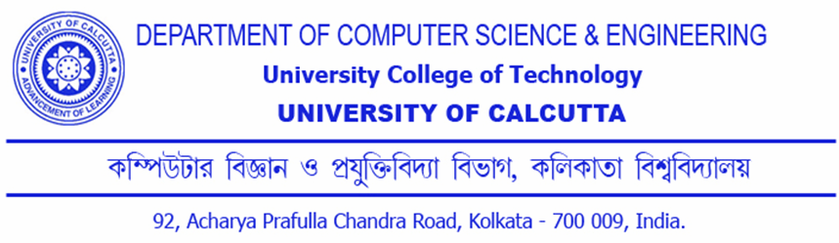

CERTIFICATION
This is to certify that the dissertation entitled “Password Authenticated Key Exchange By Juggling” is the bonafide work of Dipendu Ghosh and Hirakjyoti Banerjee and has been prepared according to the regulations for award of the degree of Master of Science in Computer and Information Science in University of Calcutta for the year 2011 and the candidate has partially fulfilled the requirements for the submission of the dissertation.

………………………………..……………. Prof. Devadatta Sinha Project Supervisor,
Computer Science & Engineering Department,
University of Calcutta
………………………………………………. Prof. Nabendu Chaki, Chairman, Board of Post Graduation Studies,
Computer Science & Engineering Department,
University of Calcutta

……………………………………….

………………………………………………………….
External Examiner

